# Chapter 2 - The Economic Problem

**Production Possibilities and Opportunity Cost**

The **Production Possibility Frontier (PPF)** is the boundary between those combination of goods and services that can be produced and those that cannot. Shows the maximum combination of outputs (goods and services) that can be produced with the given resources and technology.

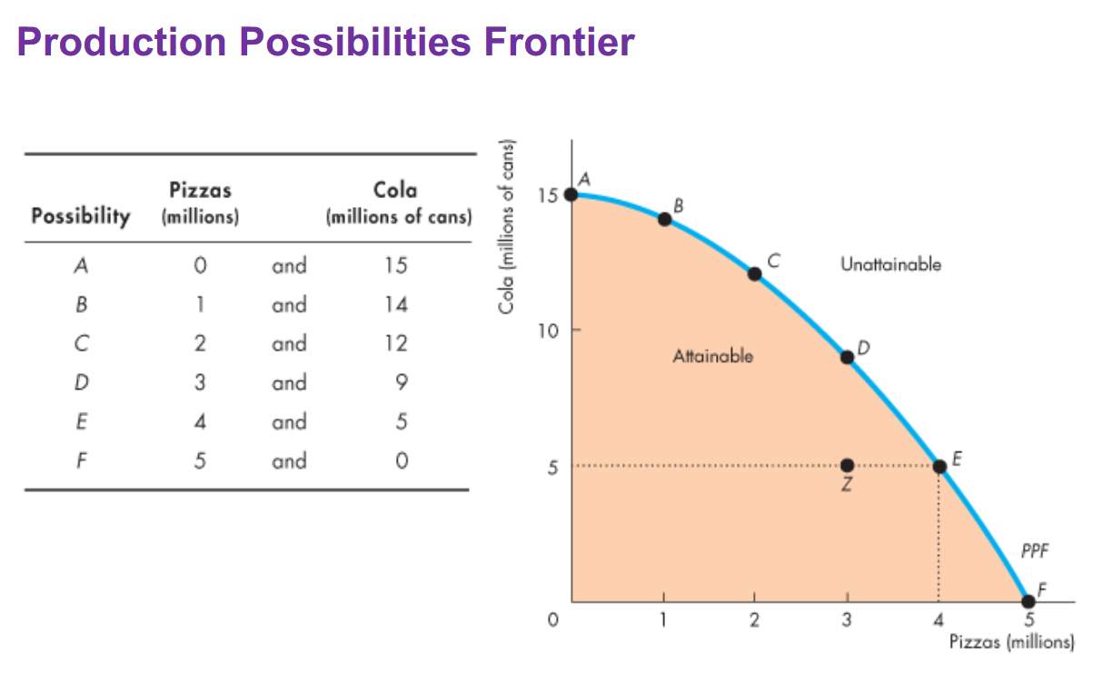

*Production Efficiency*

**Production efficiency** is reached if we cannot produce more of one good without producing less of one good. All the points on the frontier are production efficiencies.

*Trade-off Along the PPF*

Every choice along the PPF involves a trade-off

NOTE: Trade-off means to get of one value we must give of the other.

*Opportunity Cost on the PPF*

The opportunity cost along the PPF is a ratio.

*Increasing Opportunity Cost*

Since the resources are not equally productive in all activities, the PPF bows outward.

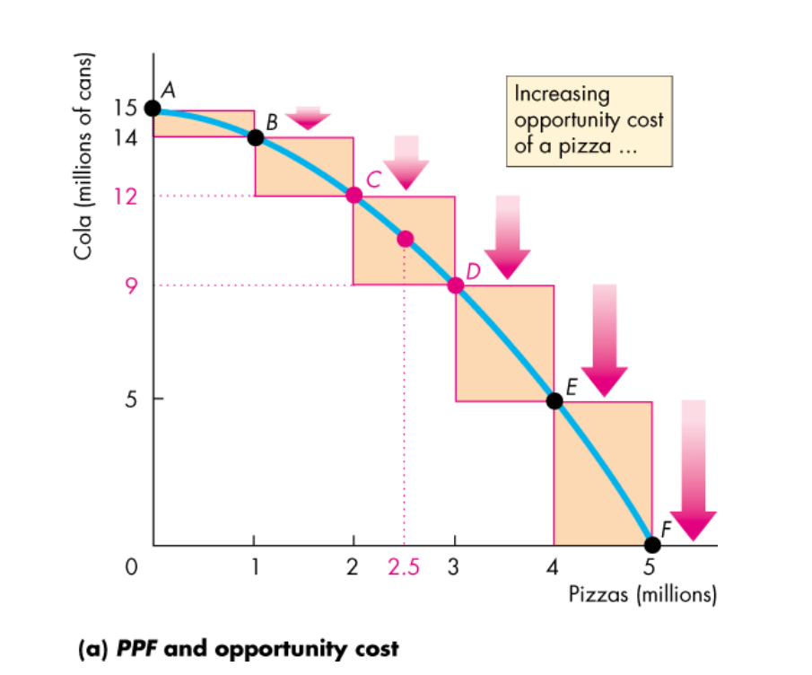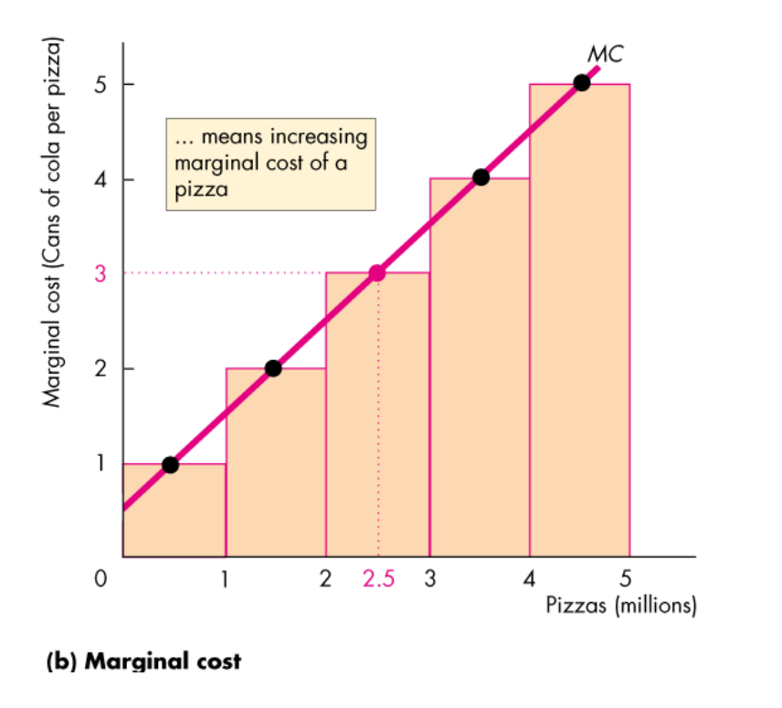

**Using Resources Efficiently**

*PPF & Marginal Cost and Preferences & Marginal Benefit*

**Marginal Cost** is the cost of producing one more unit of a quantity.

**Marginal Benefit** of a good or service is the benefit of consuming one more unit of it.

**Principle of Decreasing Marginal Benefit – “***The more we have of any good, the smaller is its marginal benefit and ... the less we are willing to pay for an additional unit of it.”*